43.42: 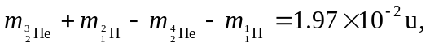 so the energy released is 18.4 MeV.

